# Class Introduction

## Introduction

Extends:

Implements:

|  |
| --- |
| Interface |
|  |
|  |

|  |
| --- |
| Class |
|  |
|  |

## Model

### Overview

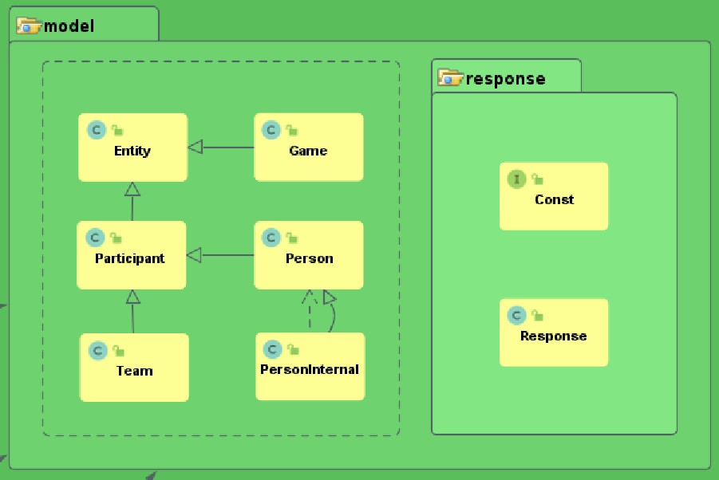

### Response

|  |
| --- |
| Const(Interface) |
| Define Const used in the system:  Status code options  Status message options  Person roles  Max length of Strings  Max round no of game  Response format |
|  |

|  |
| --- |
| Response<T extends Entity> |
| +statusCode: int  +statusMsg: String  +entities: ArrayList<T> |
|  |

### Entities

|  |
| --- |
| Entity |
| +Id: Integer |
|  |

|  |
| --- |
| Game |
| +roundNo: Byte  +team1: Integer  +team2: Integer  +winner: Integer  +team1Name: String  +team2Name: String  +winnerName: String |
|  |

|  |
| --- |
| Participant |
| +name: String |
|  |

|  |
| --- |
| Team |
|  |
|  |

|  |
| --- |
| Person |
| +idDocNumber: String  +teamId: Integer |
|  |

|  |
| --- |
| PersonInternal |
| +role: Byte |
| +PersonInternal()  +PersonInternal(Person person, Byte role) |

## Repository

### Overview

|  |
| --- |
| BaseRepository |
| #dbApi: DbApi |
|  |

|  |
| --- |
| GameRepository |
|  |
|  |

|  |
| --- |
| ParticipantRepository |
|  |
|  |

|  |
| --- |
| TeamRepository |
|  |
|  |

|  |
| --- |
| PersonRepository |
|  |
|  |

|  |
| --- |
| CoachRepository |
|  |
|  |

|  |
| --- |
| PlayerRepository |
|  |
|  |

|  |
| --- |
| IBaseRepository |
|  |
|  |

### DbApi

|  |
| --- |
| DbApi |
| -mySqlHost: String  -mySqlPort: String  -mySqlDb: String  -mySqlUsername: String  -mySqlPassword: String  -dataSource: HikariDataSource  -lock: Lock |
| +finalize()  -initialize()  ~getConnection(): Connection  ~readByColumn(String colName, String tableName, Class<? extends Entity> cls, Object colValue): Response  ~readTable(String tableName, Class<? extends Entity> cls): Response  ~readByFilters(String tableName, Class<? extends Entity> cls, String filters, ArrayList<Object> parameters): Response  ~read(String sql, Class<? extends Entity> cls): Response  ~read(String sql, ArrayList<Object> parameters, Class<? extends Entity> cls): Response  -getResultColumnFieldMap(Class cls, ResultSetMetaData resultSetMetaData): HashMap<String, Field>  ~read(Connection connection, String sql, ArrayList<Object> parameters, Class<? extends Entity> cls): Response  -getColNames(Connection connection, String tableName): ArrayList<String>  ~write(Optional<? extends Entity> optionalEntity, String tableName): Response  ~write(Connection connection, Optional<? extends Entity> optionalEntity, String tableName): Response  ~delete(Integer id, String tableName): Response  ~delete(Connection connection, Integer id, String tableName): Response  ~executeNonQuery(String sql, ArrayList<Object> parameters): Response  ~executeNonQuery(Connection connection, String sql, ArrayList<Object> parameters): Response |

### **IBaseRepository**

|  |
| --- |
| IBaseRepository |
|  |
| +readAll(): Response<? extends Entity>  +readById(Integer id): Response<? extends Entity>  +delete(Integer id): Response |

### BaseRepository

|  |
| --- |
| BaseRepository |
| #dbApi: DbApi |
| +BaseRepository(DbApi dbApi)  #readById(Integer id, String tableName, Class cls): Response |

### GameRepository

|  |
| --- |
| GameRepository |
| #teamRepository: TeamRepository  -tableName: String  -cls: Class  -sqlReadAll: String |
| +GameRepository(DbApi dbApi, TeamRepository teamRepository)  +readAll(): Response  +readById(Integer id): Response  +read(Byte roundNo, Integer team1, Integer team2): Response  +setGameResult(Integer id, Integer winner): Response  +write(Game game): Response  +delete(Integer id): Response |

### ParticipantRepository

|  |
| --- |
| ParticipantRepository |
|  |
| +ParticipantRepository(DbApi dbApi)  #readByName(String name, String tableName, Class cls): Response |

### TeamRepository

|  |
| --- |
| TeamRepository |
| -tableName: String  -cls: Class  -sql4IsChildExists: String |
| TeamRepository(DbApi dbApi)  +readAll(): Response  +readById(Integer id): Response  +isChildExists(Integer id): Resonse  +readByName(String name): Response  +write(Team team): Response  +delete(Integer id): Response |

### PersonRepository

|  |
| --- |
| PersonRepository |
| #teamRepository: TeamRepository  -tableName: String  -clsOutput: Class  -clsOutput1: Class |
| PersonRepository(DbApi dbApi, TeamRepository teamRepository)  #readByRole(Byte role): Response  #readById(Integer id, Byte role): Response  +readByIdDocNumber(String idDocNumber): Response  #write(Person person, Byte role): Response  #delete(Integer id, Byte role): Response |

### CoachRepository

|  |
| --- |
| CoachRepository |
|  |
| CoachRepository(DbApi dbApi, TeamRepository teamRepository)  +readAll(): Response  +readById(Integer id): Response  +write(Person person): Response  +delete(Integer id): Response |

### PlayerRepository

|  |
| --- |
| PlayerRepository |
|  |
| +PlayerRepository(DbApi dbApi, TeamRepository teamRepository)  +readAll(): Response  +readById(Integer id): Response  +write(Person person): Response  +delete(Integer id): Response |

## Service

|  |
| --- |
| IService |
|  |
|  |

### Overview

|  |
| --- |
| CoachService |
|  |
|  |

|  |
| --- |
| PlayerService |
|  |
|  |

|  |
| --- |
| GameService |
|  |
|  |

|  |
| --- |
| TeamService |
|  |
|  |

### **IService**

|  |
| --- |
| IService(Interface) |
|  |
| readAll(): Response<? extends Entity>  readById(Integer id): Response<? extends Entity>  delete(Integer id): Response |

### **TeamService**

|  |
| --- |
| TeamService |
| -teamRepository: TeamRepository |
| +TeamService(TeamRepository teamRepository)  +readAll(): Response<Team>: Response<Team>  +readById(Integer id): Response<Team>  +write(Team team): Response  +delete(Integer id): Response |

### **GameService**

|  |
| --- |
| GameService |
| -gameRepository: GameRepository |
| +GameService(GameRepository gameRepository)  +readAll(): Response<Game>  +readById(Integer id): Response<Game>  +setGameResult(Integer id, Integer winner): Response  +write(Game game): Response  +delete(Integer id): Response |

### **CoachService**

|  |
| --- |
| CoachService |
| -coachRepository: CoachRepository |
| +CoachService(CoachRepository coachRepository)  +readAll(): Response<Person>  +readById(Integer id): Response<Person>  +write(Person person): Response  +delete(Integer id): Response |

### **PlayerService**

|  |
| --- |
| PlayerService |
| -playerRepository: PlayerRepository |
| +PlayerService(PlayerRepository playerRepository)  +readAll(): Response<Person>  +readById(Integer id): Response<Person>  +write(Person person): Response  +delete(Integer id): Response |

## Controller

|  |
| --- |
| IController |
|  |
|  |

### **Overview**

|  |
| --- |
| CoachController |
|  |
|  |

|  |
| --- |
| PlayerController |
|  |
|  |

|  |
| --- |
| GameController |
|  |
|  |

|  |
| --- |
| TeamController |
|  |
|  |

### **IController**

|  |
| --- |
| IController |
|  |
| +readAll(): Response<? extends Entity>  +readById(Integer id): Response<? extends Entity>  +delete(Integer id): Response |

### **TeamController**

|  |
| --- |
| TeamController |
| -teamService: TeamService |
| +TeamController(TeamService teamService)  +readAll(): Response<Team>  +readById(@RequestParam Integer id): Response<Team>  +write(@RequestBody Team team): Response  +delete(@RequestParam Integer id): Response |

### **GameController**

|  |
| --- |
| GameController |
| -gameService: GameService |
| +GameController(GameService gameService)  +readAll(): Response<Game>  +readById(@RequestParam Integer id): Response<Game>  +setGameResult(@RequestParam Integer id, @RequestParam Integer winner): Response  +write(@RequestBody Game game): Response  +delete(@RequestParam Integer id): Response |

### **CoachController**

|  |
| --- |
| CoachController |
| -coachService: CoachService |
| +CoachController(CoachService coachService)  +readAll(): Response<Person>  +readById(@RequestParam Integer id): Response<Person>  +write(@RequestBody Person coach): Response  +delete(@RequestParam Integer id): Response |

### **PlayerController**

|  |
| --- |
| PlayerController |
| -playerService: PlayerService |
| +PlayerController(PlayerService playerService)  +readAll(): Response<Person>  +readById(@RequestParam Integer id): Response<Person>  +write(@RequestBody Person coach): Response  +delete(@RequestParam Integer id): Response |

## Test

|  |
| --- |
| TestBase |
|  |
|  |

### Overview

|  |
| --- |
| TeamControllerTest |
|  |
|  |

|  |
| --- |
| GameControllerTest |
|  |
|  |

|  |
| --- |
| PersonTest |
|  |
|  |

|  |
| --- |
| PlayerControllerTest |
|  |
|  |

|  |
| --- |
| CoachControllerTest |
|  |
|  |

### TestBase

|  |
| --- |
| TestBase |
| #mockMvc: MockMvc  #BASE_URL_TEAM: String  #BASE_URL_GAME: String  #BASE_URL_COACH: String  #BASE_URL_PLAYER: String  #gson: Gson  #INVALID_STATUS: int  #INVALID_ID: int  -APPLICATION_JSON_UTF8: MediaType |
| #isStatusCodeValid(int statusCode): boolean  #getStr(int length): String  #readAll(String url)  #readById(String url, Integer id): int  #writeOnce(String url, Optional<? extends Entity> optionalEntity, int expectedResultCode, int unUxpectedResultCode): int  #writeATeam(): int  #writeAGameForATeam(Integer team1, Integer team2): int  #writeAGame(): int  #writeAPersonForATeam(String baseUrl, Integer teamId): int  #writeAPerson(String url): int  #deleteAGame(int id, int expectedResultCode, int unUxpectedResultCode)  #deleteAPerson(String baseUrl, int id, int expectedResultCode, int unUxpectedResultCode)  #delete(String url, Integer id, int expectedResultCode, int unUxpectedResultCode) |

### TeamControllerTest

|  |
| --- |
| TeamControllerTest |
|  |
| ~readAll()  ~readById()  ~writeOnce(Team team, int expectedResultCode, int unUxpectedResultCode): int  ~write()  ~delete(int id, int expectedResultCode, int unUxpectedResultCode)  ~delete() |

### GameControllerTest

|  |
| --- |
| GameControllerTest |
|  |
| ~readAll()  ~readById()  ~writeOnce()  ~writeOnce(Game game, int expectedResultCode, int unUxpectedResultCode): int  ~write()  ~delete()  ~setGameResult()  -setGameResult(Integer id, Integer winner , int expectedResultCode, int unUxpectedResultCode) |

### PersonTest

|  |
| --- |
| PersonTest |
|  |
| ~writeACoach(): int  ~writeAPlayer(): int  ~writeOnce(String url, Person person, int expectedResultCode, int unUxpectedResultCode): int  ~write(String url) |

### CoachControllerTest

|  |
| --- |
| CoachControllerTest |
|  |
| ~readAll()  ~readById()  ~write()  ~delete(int id, int expectedResultCode, int unUxpectedResultCode)  ~delete() |

### PlayerControllerTest

|  |
| --- |
| PlayerControllerTest |
|  |
| ~readAll()  ~readById()  ~write()  ~delete(int id, int expectedResultCode, int unUxpectedResultCode)  ~delete() |